# Introduction

# The Church Financial Record Keeping application is a web-based application designed to record donations made to the Church. This user manual assists the user by providing a step by step guide on how to:

* Login to the application
* Add/Edit/Delete members
* Add/ Edit/Delete funds
* Add/Edit/Delete donations made to the church
* Generate reports

1. **Overview of the Document**

Section 3 gives information on the system requirements, Section 4 describes the installation instructions of client’s software, Section 5 shows how to login to the application, Section 7 gives an idea on how to add/edit/delete members, Section 8describes how to add/edit/delete funds, Section 9describes how to add/edit/delete donations, Section 10 shows how to generate reports

1. **System Requirements**

Before accessing the web application, make sure your computer meets the following minimum system requirements:

* Windows 7/8/8.1/10
* Dual core Processor
* 1 GB RAM
* 40 GB Hard Disk
* One of the following web browsers: Microsoft Internet Explorer or Google Chrome or Mozilla Firefox.
* Microsoft Visual Studio 10
* Microsoft SQL Server 12

1. **Installation Instructions**

**Client Installation -Microsoft Windows SQL Server**

The installation and configuration for Church Record Keeping software should be setup by a professional IT person. The qualified professional should have access to Microsoft Windows SQL Server and can use Microsoft Server Management Studio for setting up the database or can run the SQL script to create a database and add the application code to it. SQL uses the Windows authentication Single mode only.

**Microsoft Visual Studio Installation**

Visual studio will be downloaded from Dream Spark for user system installation. MSU students and faculty have access to the dream spark for development software provided from Microsoft. It will provide executable file (.exe file). One of the support team members will install executable file on the user’s system by following step by step instructions. The team member will also integrate the Church Financial Record Keeping project Application in to Visual Studio.

1. **Log In**

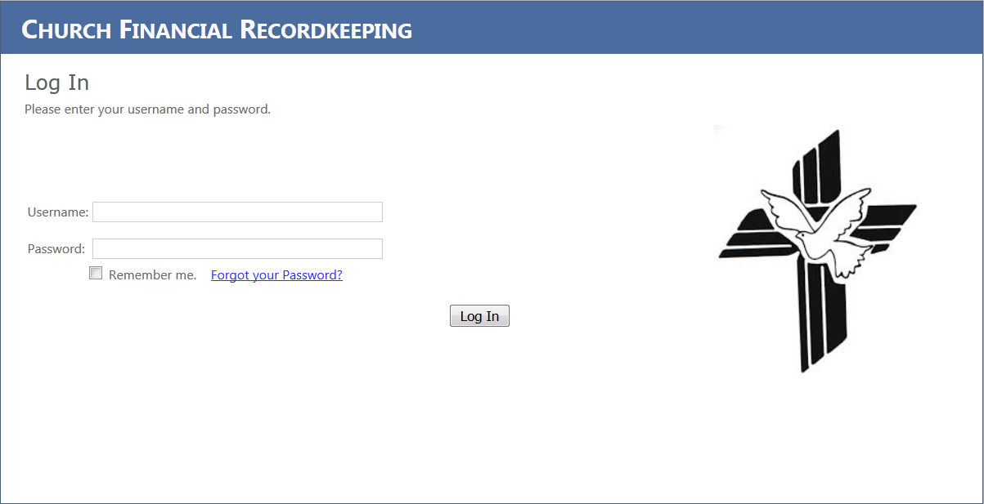

Screen 1-Login

To get started using the application, you must login using the admin provided user credentials by entering the **username** and **password** in their respective fields and click “Log In” button as shown in Screen 1.

If the user has forgotten login password, then the user needs to click on **Forgot your Password?** link, as shown in Screen 1. Now a message appears describing on how to retrieve user credentials by contacting system administrator.

1. **Site Navigation**

Once the user successfully logs into the system he/she can navigate among site featuring using the menu bar at the top, which includes access to the following application functions.

* Member: User can Add/Edit/Delete members in this section
* Fund: User can Add/Edit/Delete funds in this section
* Donation: User can Add/Edit/Delete donations in this section
* Report: User can generate reports of donations from this section

1. **Member**

Click on **Member** tab from menu bar at the top. In Screen 3 you see two tabs, **Add New Member** and **View Members**. Select the appropriate tab in order to add/edit/delete members.

* 1. **To Add a New Member**

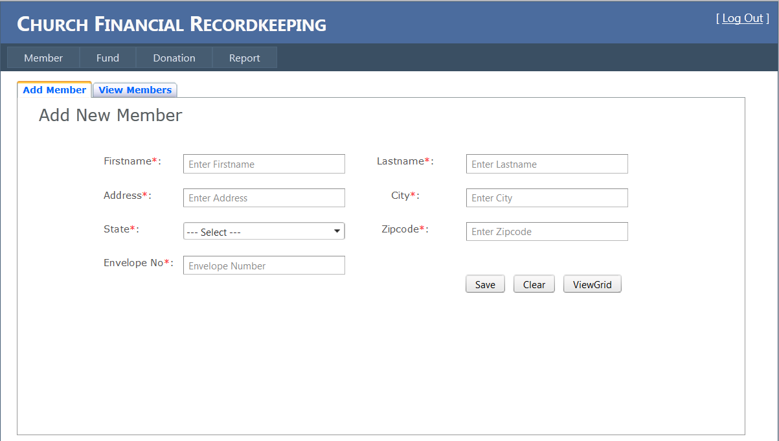

Screen 2- Add Member

As shown in Screen 2, click on **Add New Member** tab and do the following:

* Enter the **Firstname, Lastname, Address, City, Zipcode, Envelope No.** in their respective fields and select the **State** from the menu list.
* Once completed, you must click **save** button to add the member on record.
* If you wish to erase all the details that he/she entered, click on **clear** button.
* If you wish to view the members on record, click on **ViewGrid** button.
  1. **To Edit a Member**

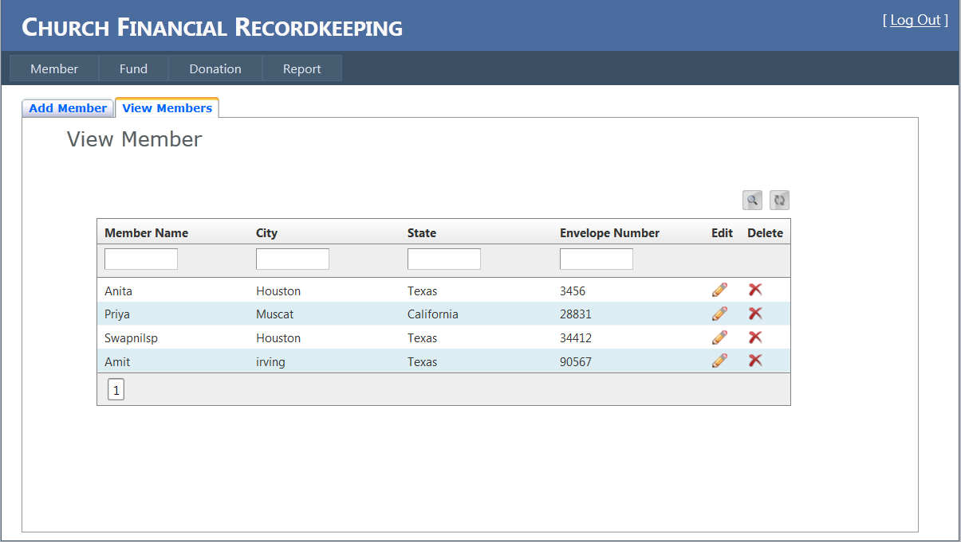

Screen 3- Edit Member

As shown in Screen 3, click on **View Members** tab and now, you see a list of members in the grid. In order to edit a member information do the following:

* Search for the member by entering his/her details(like either Member Name or City or State or Envelope No.) in the boxes located below each field and click on search (****) icon.
* You can see an edit (pencil.png) icon associated with each member record in the grid.
* Click on edit (pencil.png) icon and now you can edit the details of member in the page.
* Once completed, you must click **save** button to update the details of member.
* Click on refresh (refresh.jpg) icon to view the updated information of member at the bottom of the page.
  1. **To Delete a Member**



Screen 4- Delete Member

As shown in Screen 4, click on **View Members** tab and now, you see a list of members in the grid. In order to delete member information, do the following:

* Search for the member by entering his/her details(like either Member Name or City or State or Envelope No.) in the boxes located below each respective field and click on search (****) icon.
* You see a delete (delete.jpg) icon associated with each member record in the grid.
* Click on delete (delete.jpg) icon to delete a member from the record.
* Click on refresh (refresh.jpg)icon to view the updated record of members in the grid.

1. **Fund**

Click on **Fund** tab from menu bar at the top. In Screen 5 you see two tabs, **Add Fund** and **View Funds**. Select the appropriate tab in order to create/edit/delete funds.

* 1. **To Create a New Fund**

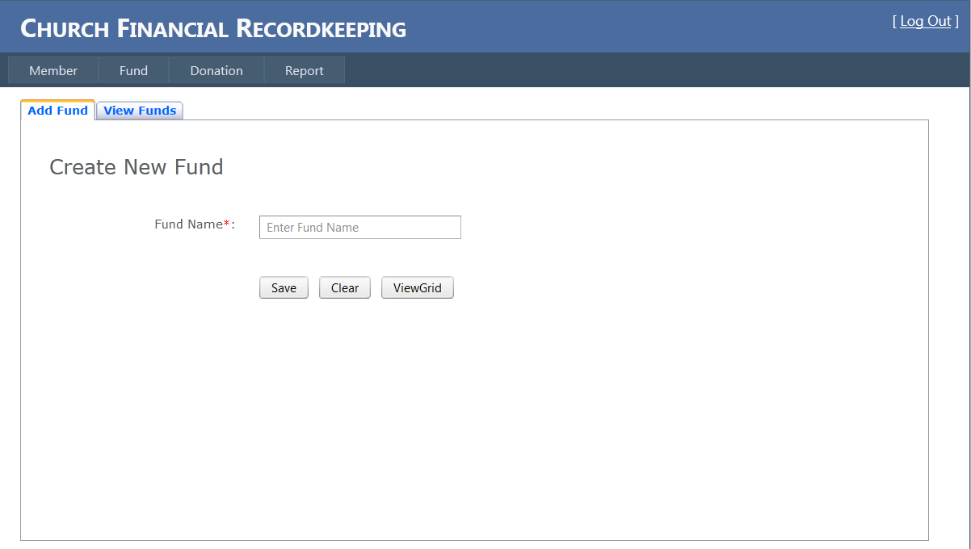

Screen 5- Create Fund

As shown in Screen 5, click on **Add Fund** tab and do the following:

* Enter the **Fund Name** in the field.
* Once completed, you must click **save** button to add the fund on record.
* Click on **clear** button if you would like to erase all the details that you entered.
* If you wish to view the funds on record, click on **ViewGrid** button.
  1. **To Edit a Fund**

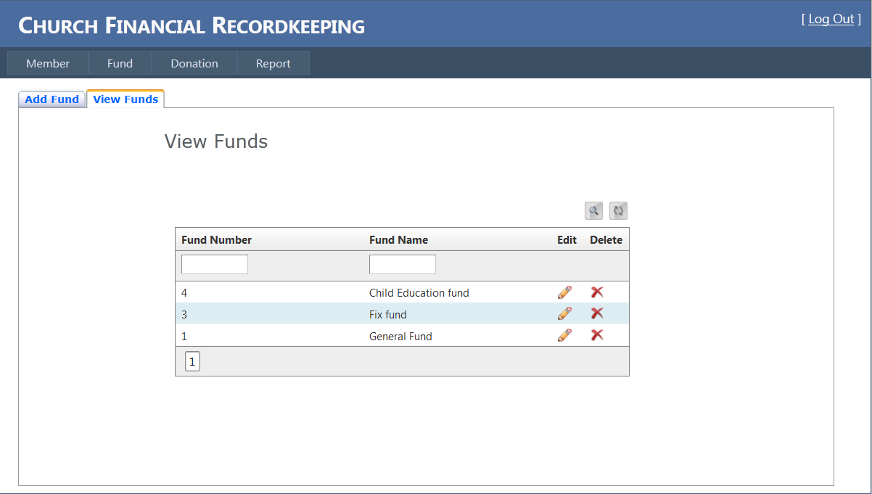

Screen 6- Edit Fund

As shown in Screen 6, click on **View Funds** tab and now, you see a list of funds in the grid. In order to edit fund information, do the following:

* Search for the fund by entering the details(like either Fund Number or Fund Name) in the boxes located below each respective field and click on search (****) icon.
* You see an edit (pencil.png) icon associated with each fund record in the grid.
* Click on edit (pencil.png) icon and now you can edit the details of fund in the page.
* Once completed, you must click **save** button to update the details of fund.
* Click on refresh (refresh.jpg) icon to view the updated information of fund in the grid.
  1. **To Delete a Fund**



Screen 7- Delete Fund

As shown in Screen 7, click on **View Fund** tab and now, you see a list of funds in the grid. In order to delete fund information, do the following:

* Search for the fund by entering the details(like either Fund Number or Fund Name) in the boxes located below each respective field and click on search (****) icon.
* You see a delete (delete.jpg) icon associated with each fund record in the grid.
* Click on delete (delete.jpg) icon to delete a fund from the record.
* Click on refresh (refresh.jpg) icon to view the updated record of funds in the grid.

1. **Donation**

Click the **Donation** tab from menu bar at the top. In Screen 9 you see two tabs, **Add Donation** and **View Donations**. Select the appropriate tab in order to create/edit/delete donations.

* 1. **To Create a New Donation**

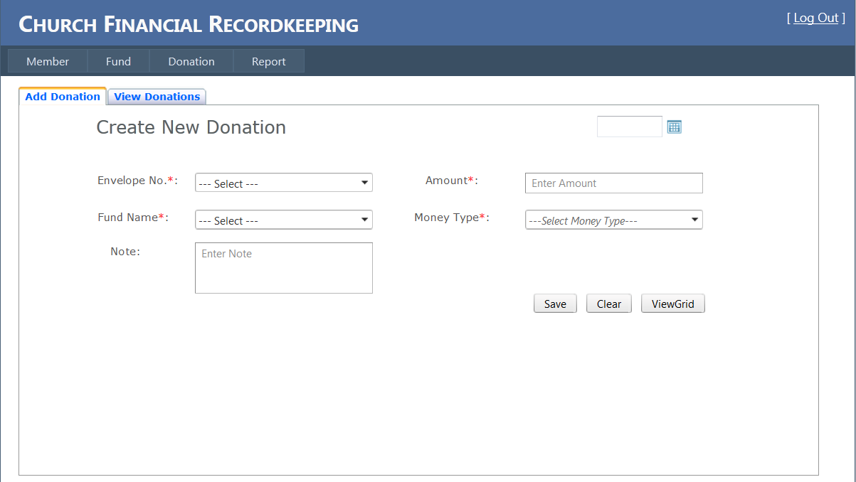

Screen 8- Create Donation

As shown in Screen 8, click on **Add Donation** tab and do the following:

* Enter the **Amount,** select the date from calendar and select the **Envelope No., Fund Name, Money Type, Date** from the menu list in their respective fields.
* Write comments for that particular donation if you wish to do any in the **Note** field.
* Once completed, you must click **save** button to add the donation on record
* Click on **clear** button if you would like to erase all the details that you entered.
* If you wish to view the donations on record, click on **ViewGrid** button.
  1. **To Edit a Donation**

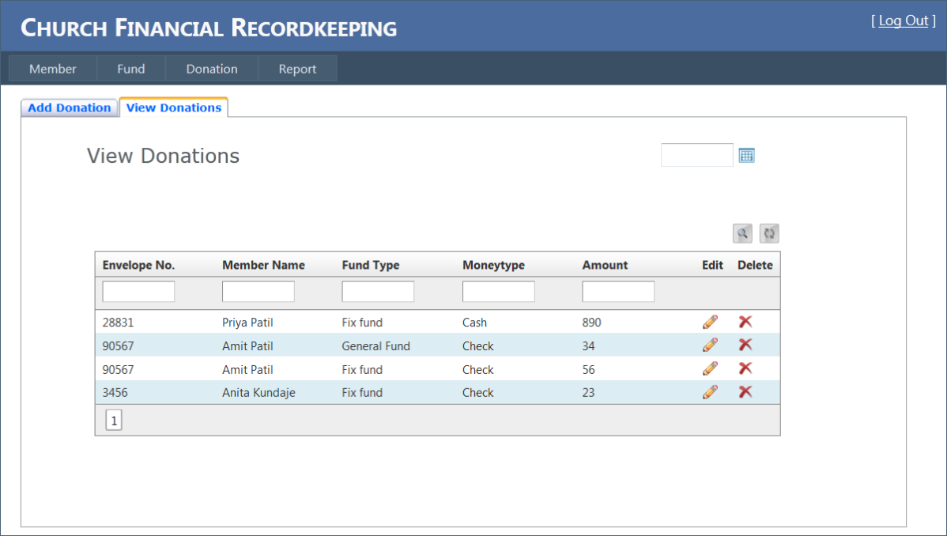

Screen 9- Edit Donation

As shown in Screen 9, click on **View Donation** tab and now, you see a list of donations in the grid. In order to edit donation information, do the following:

* Search for the donation by entering the details(like either Envelope No., Member Name, Fund Type, Money Type, Amount) in the boxes located below each respective field and click on search (****) icon.
* You see an edit (pencil.png) icon associated with each donation record in the grid.
* Click on edit (pencil.png) icon and now you can edit the details of donation in the page.
* Once completed, you must click **save** button to update the details of donation.
* Click on refresh (refresh.jpg) icon to view the updated information of donations in the grid
  1. **To Delete a Donation**

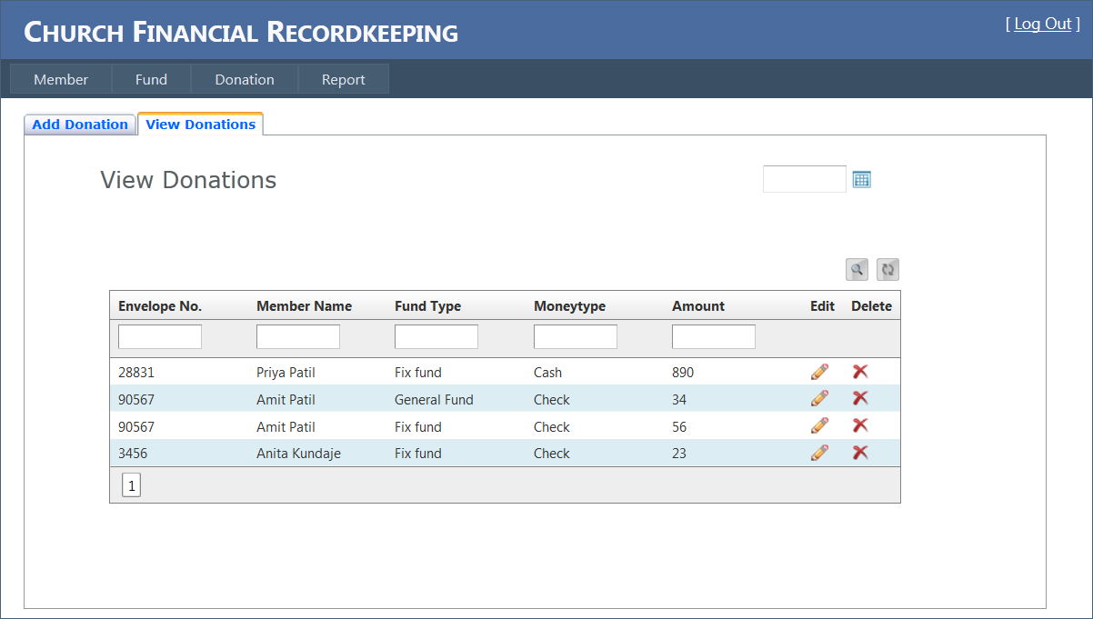

Screen 10- Delete Donation

As shown in Screen 10, click on **View Donation** tab and now, you see a list of donations in the grid. In order to delete donation information, do the following:

* Search for the donation by entering the details(like either Envelope No., Member Name, Fund Type, Money Type, Amount) in the boxes located below each respective field and click on search (****) icon.
* You see a delete (delete.jpg) icon associated with each donation record in the grid.
* Click on delete (delete.jpg) icon to delete a donation from the record.
* Click on refresh (refresh.jpg) icon to view the updated record of donations in the grid

1. **Report**

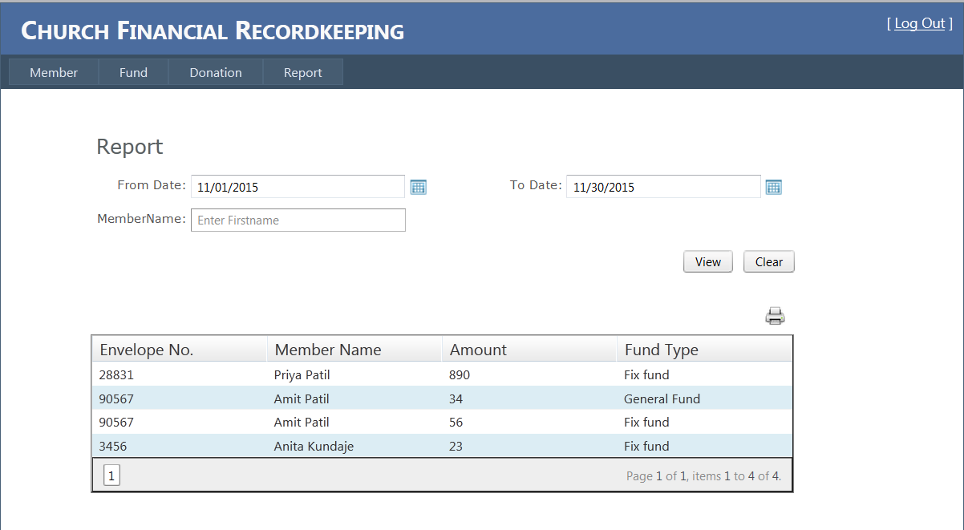

Screen 11 -Report

Click the **Report** tab from menu bar at the top if you would like to generate reports (like either annual reports or monthly reports or weekly reports or daily reports) and do the following:

* Enter the **From Date** and **To Date** in their respective fields if you need the report for specific period.
* Enter **Member Name** if you would like to generate report for that particular member.
* Click on **view** button to display the report in the grid.
* Click on **clear** button if you would like to erase all the details that you entered.
* Click on print () icon for printing the report.
* You can also save the report on your hard disk if you don’t wish to print.

1. **Log Out**

After you are done with using your application, be sure to logout by clicking the **[Log Out]** button located at the top-right corner of the page and close your browser (all windows). This protects your information.

1. **Support**

Contact Church Financial Record Keeping team for any help regarding the application via Phone: 9403376035 or email: sas4money@gmail.com, [sapna.patil1110@gmail.com](mailto:sapna.patil1110@gmail.com), [kranthi610@gmail.com](mailto:kranthi610@gmail.com), mrudula.kosaraju17@gmail.com.

1. **Glossary**

Client- The party for which services is rendered.

Database- Files containing the collection of data for the software.

SQL Server- Database management software

Microsoft Visual Studio- It’s a framework which will be used in designing and coding from Microsoft Corporation.

Microsoft Windows- A family of operating systems from Microsoft Corporation.

1. **References**

* “United States Department of Housing and Urban Development” user manual template, from Google: https://portal.hud.gov/hudportal/documents/huddoc? id= DOC _15160.doc
* Sommerville, I., Software Engineering 9th edition book, Pearson (March 2004).
* SCORS and SOCS user manual drafts provided by Professor Dr. Stringfellow.